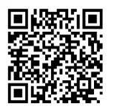
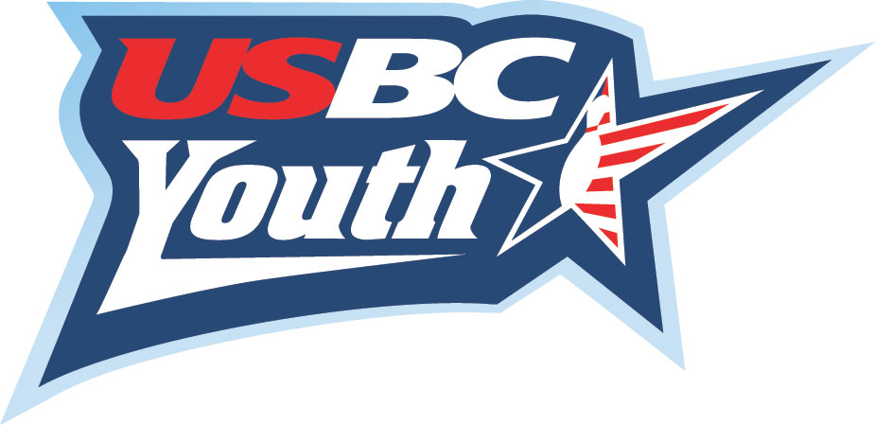

SARASOTA – MANATEE 3-6-9
SCHOLARSHIP TOURNAMENT
***This is a Singles Tournament***
(Proceeds benefit the Sarasota-Manatee Scholarship Fund)

***Sunday, December 7, 2025 at Bowlero Bradenton***
4208 Cortez Rd, Bradenton 941-758-8838
****Check in Noon, Bowl at 1:00 PM****

This tournament is for both sanctioned Youth and Adult bowlers,
with separate divisions for the Youth bowlers.

Adult Division Youth Divisions
Cash prizes Scholarship prizes
Pays 1 in 6 ratio Scholarships on 1 in 6 ratio

Entry fee is $30.00 per person Entry fee is $30.00 per person
$ 16.00 for lineage $ 16.00 for lineage
$ 12.00 for prize fund $ 12.00 for scholarship prize
$ 2.00 for scholarship fund $ 2.00 for scholarship fund

- This is a sanctioned tournament for Sarasota-Manatee County certified bowlers only. Bowlers will bowl THREE games scratch. Check in at Noon, squad time is 1:00 p.m.
- Current Winter 2024-2025 yearbook average will be used. If no winter, Summer 2025. (21 games, bowlers must bring verification with them) All other averages are at tournament directors’ discretion. Youth bowlers will be separated into three divisions based on their entering averages – 151 and over, 121 to 150, and 120 and under. No separate division for boys or girls. All scholarship prizes will be held by the SMART program as per USBC guidelines.
- Contact Sandy Combs (941-932-7594) or Karen Shaffer (941-544-4441), with any questions.

1:00pm

Adult Youth

(circle one please)

Name:_________________________________________________________

Address:_______________________________________________________

City, Zip:________________________________________________________

Phone:__________________________________________________________

Email:__________________________________________________________

USBC #________________________Average:____________________

Bowling Center:________________Paid:________________________

**Mail advance entries to:

Sandy Combs PO Box 20027 Bradenton, FL 34204


