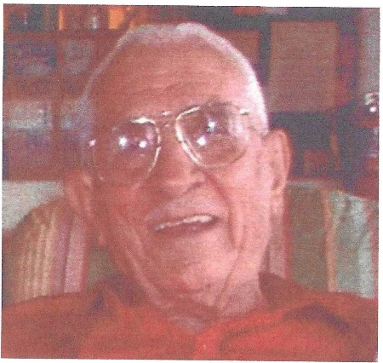
Andy Rapone Memorial
Best 3 out of 4
Singles Tournament
Handicap 90% of 240
BOWL 4 GAMES, USE BEST 3
Saturday, February 7, 2026
Check-In at NOON BOWL at 1:00 PM
Bowlero Gulfgate 7221 S Tamiami Trl
941/921-4447
2 Divisions: 175 & Above and 174 & Below
Hosted by Sarasota/Manatee Men’s Hall of Fame

ENTRY FEE: $35 per Bowler***
Prize Fund (Returned 100%) $12.00
Bowling Fee $18.00
Expense Fee (Hall of Fame) $5.00
$35.00
***Pre-registered Only
Day of Tournament $40.00 per bowler

SIDE TOURNAMENTS AND POTS AVAILABLE AND WILL USE ALL 4 GAMES
(You must be entered in the Handicap Tournament to participate in the side pots.)
Scratch Tournament open to all bowlers $10
Senior 50+ Tournament $10
Ladies Only Handicap Tournament $10
Handicap Brackets with starts in Game 1 and 2. $5 each
Handicap High Game Pots for all 4 Games $10
Scratch Brackets with starts in Game 1 and 2. $5 each Tournament Director:
Scratch High Game Pots for all 4 Games $10 Chuck Souzer
Virtual Doubles Game 2 $10 per team 5259 Villa Majorca Ct.
Sarasota, FL 34235
Rules and entry form are on back. 941.320.4584
1. Operation:
All USBC rules and regulations will govern this tournament unless speciﬁcally waived below. All entrants must check in no later than 30 minutes prior to squad time.
2. Eligibility:
All entrants must be at least 14 years old and be a current member of a USBC Association. If not local association, entrants must provide average veriﬁcation from their Association Manager. USBC cards must be presented at check in.
3. Entering Average:
All entrants must use their highest 24-25 USBC winter average. Any bowler without a 24-25 winter average may use 2025 summer league average based on 21 or more games, provided they submit a written veriﬁcation. All others will bowl scratch. The tournament management reserves the right to adjust any bowler’s average upward prior to their participation in the tournament. Failure to use the proper average shall disqualify score if submitted average is lower than their actual average. If reported average is higher than actual average, the higher average will be used for this tournament. All averages must correspond to bowling style. (Entrants bowling right-handed must use right-handed average and handicap, while entrants bowling left-handed must use left-handed average and handicap. 10 pin rule is waived. Rule 319D Applies (reporting prior prize money’s Certified or Non-Certified)
4. Handicap:
All prizes will be on a handicap basis unless specified as scratch. The handicap will be 90% of the entrant’s average from 240 scratch based on 21 games or more.
5. Bowler’s Responsibility
It shall be the bowler’s responsibility to verify his or her average.
6. Fees:
There will be a $2 HOF expense fee for all side tournaments and pots. Fees will not be refunded after the entry form and fees have been received.
7. Awards:
All prize monies will be returned 100% on a ratio of at least (1) prize for each (6) entries. In the event of a tie for the tournament, prize monies will be equally divided. Any youth prize money will be sent to their SMART account.

________________________________________________________________________________________

OFFICIAL ENTRY BLANK

Name:__________________________ USBC#___________

Address___________________________________________

City_________________ Zip_______Phone_______________

Highest 24-25 USBC Winter Average:_____, If No Winter, Summer 2025____

Email:______________________DATE OF BIRTH:_________

Signature________________________ Amount Paid______

